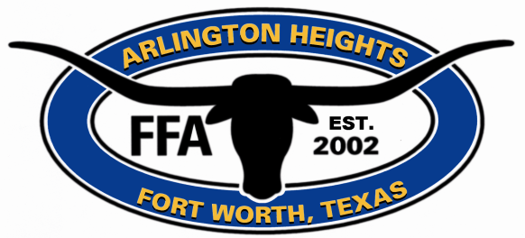
Arlington Heights High School Future Farmers of America Alumni Association
AHHS FFA Alumni Scholarship committee is taking entries for this year’s (2023-2024) scholarship. Open to all Ag and FFA students (Spring Semester Seniors only). Delivered to the Alumni Assoc. by 6:30 on Tues April 9th. No late entries will be accepted! Applicants will also be required to be present for a follow-up interview conducted by the AHHS FFA Alumni Scholarship committee on April 23rd after school.
Proper FFA attire is required for the interview!
Proper use of grammar and spelling is a must. Recipients will be announced at the banquet on May 2nd, 2024. Students interested in applying for the AHHS FFA Alumni Scholarship will be required to hand-submit the following three items to the committee prior to the interview date:
- Applicants will be required to hand-submit a typed essay (min 1200 words) in response to the following question:
“How has FFA/Ag impacted your life and do you believe that your experiences as a student in Agriculture and/or FFA member will help you overcome the challenges you will be faced within the near future”.
- Applicants will be required to hand-submit a typed application outlining the following information:
Student’s name (required).
Student’s contact information (required).
Fill out attached form: Student’s FFA Achievements to include details of each of the following (required):
- List FFA Offices Held,
- List FFA Honors/Awards,
- List all FFA Team Participation,
- List all FFA Sponsored Activities,
- List all Supervise Ag Education Programs participated in
- List all Animals Raised or Ag projects completed.
Note: if none for any of the achievements, please indicate NONE (all 6 categories required).
Additional non-FFA scholastic information is highly encouraged and may include: academic honors, school activities, leadership and organization, community service, extracurricular activities and work experience.
- Applicants will be required to hand-submit an “official” copy of the student’s academic achievement record obtained from an AHHS counselor/teacher. This record will contain student’s GPA (use weighted) and list of Ag classes (use completed classes only)

Applicant's Name
_______________

Address
___________________

City, State, Zip
____________________

Phone #
__________________

Parent/Guardian’s Name:

School/College/University you plan to attend:

Future Goals:

ACT/SAT scores High School GPA

FFA OFFICES HELD

School Year | FFA Office |  | Greenhand | Chapter | District | Area

Individual FFA honors won (individual CDEs, LDEs, special awards, public speaking, exhibiting livestock & awards, FFA degrees, etc…).
DO NOT DUPLICATE ACTIVITIES LISTED IN PRECEEDING COLUMNS
School Year | FFA Achievement | Local | District | Area | State | National

FFA Team Participation (LDEs, CDEs, Ag Science Fairs, talent teams, etc...). DO NOT DUPLICATE ACTIVITIES LISTED IN PRECEEDING COLUMNS

School Year | FFA Achievement | Local | District | Area | State | National

Other FFA Sponsored Activities (committees, radio & televisions activities, FFA Banquets, FFA Camps, leadership schools, SAE programs, Barn Tours). DO NOT DUPLICATE ACTIVITIES LISTED IN PRECEEDING COLUMNS

School Year | Other Activities | Local | District | Area | State | National

List your school activities, awards, and/or offices (4H, Student Council, Drama, etc…). DO NOT DUPLICATE ACTIVITIES LISTED IN PRECEEDING COLUMNS

School Year | School activities, awards ,offices | Local | District | Area | State | National

Animal projects (animals raised) or Ag projects completed. DO NOT DUPLICATE ACTIVITIES LISTED IN PRECEEDING COLUMNS

School Year | Project

Essay: In a minimum of 1200 words please describe Your most memorable FFA experience and how this experience or other experiences you may have had in FFA has better prepared you for life after High School.

Interview: Please prepare a 2-5min introduction of yourself and be prepared to answer questions in front of the Alumni Association Scholarship Committee.

Please contact Mr Ritz at (817) 996-0661 or gregritz@sbcglobal.net or any Ag teacher for any questions regarding the process

Deadline to turn in application and essay:

Hand Deliver on Tuesday April 9, 2024, by 06:30pm of the scheduled FFA meeting (no late submittals will be accepted)

In person interviews will be on:

April 23, 2024, after school (full FFA uniform required)

Email completed form and essay to:

Greg Ritz: gregritz@sbcglobal.net

